Module 19: Data Visualization using Matplotlib and Seaborn
We use Matplotlib and Seaborn in Python primarily for data visualization. Both libraries help you understand data better by creating plots, charts, and graphs — but they have different strengths.

✅ Why We Use Them:
- Matplotlib
- It's the foundation of data visualization in Python.
- Allows you to create basic to advanced plots (line, bar, scatter, histogram, etc.).
- Highly customizable (control every element of a plot).
- Works well with NumPy and Pandas.
- Seaborn
- Built on top of Matplotlib.
- Designed for statistical visualizations.
- Works very well with Pandas DataFrames.
- Has beautiful default styles and easier syntax for complex plots (e.g., boxplots, heatmaps, violin plots).

- Line plots
Create a new Python file, e.g., line_plot_example.py
import matplotlib.pyplot as plt
# Sample data
x = [1, 2, 3, 4, 5]
y = [10, 20, 25, 30, 40]
# Create line plot
plt.plot(x, y, marker='o', linestyle='-', color='blue', label='Sales')
# Add labels and title
plt.xlabel("Days")
plt.ylabel("Revenue")
plt.title("Sales Over Time")
plt.legend()
# Show the plot
plt.show()
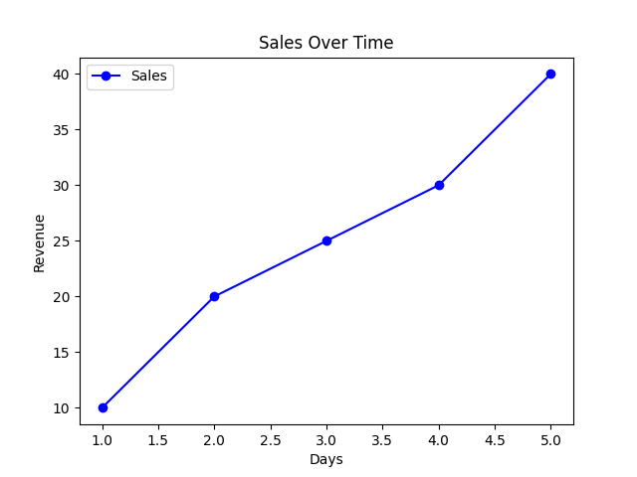

- Multiline plots

import matplotlib.pyplot as plt
# Sample data
days = [1, 2, 3, 4, 5]
product_A_sales = [10, 15, 20, 25, 30]
product_B_sales = [5, 10, 15, 10, 20]
product_C_sales = [12, 18, 22, 28, 35]

# Plotting multiple lines
plt.plot(days, product_A_sales, label="Product A", marker='o')
plt.plot(days, product_B_sales, label="Product B", marker='s')
plt.plot(days, product_C_sales, label="Product C", marker='^')

# Add labels, title, and legend
plt.xlabel("Days")
plt.ylabel("Sales")
plt.title("Sales Comparison Over Days")
plt.legend()

# Optional: Add grid
plt.grid(True)

# Show plot
plt.show()
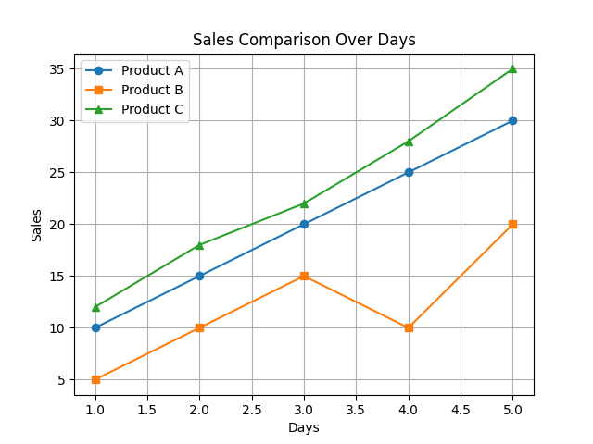

- Bar plot

import matplotlib.pyplot as plt
# Sample data
products = ['Product A', 'Product B', 'Product C', 'Product D']
sales = [150, 200, 180, 130]
# Create a bar plot
plt.bar(products, sales, color='skyblue')
# Add labels and title
plt.xlabel('Products')
plt.ylabel('Sales')
plt.title('Sales by Product')
# Show the plot
plt.show()
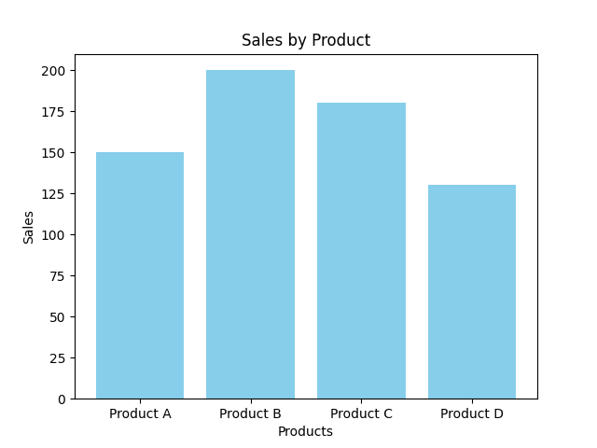

- Histogram

import matplotlib.pyplot as plt
# Sample data: student marks
marks = [45, 55, 65, 70, 75, 80, 85, 90, 92, 95, 45, 55, 60, 65, 70, 75, 80]

# Create histogram
plt.hist(marks, bins=5, color='orange', edgecolor='black')
# Add labels and title
plt.xlabel('Marks Range')
plt.ylabel('Number of Students')
plt.title('Distribution of Student Marks')
# Show plot
plt.show()
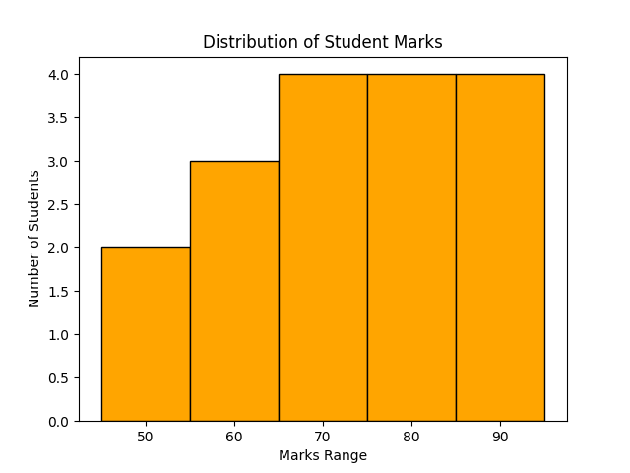

- Pie chart

import matplotlib.pyplot as plt
# Sample data
labels = ['Product A', 'Product B', 'Product C', 'Product D']
sales = [250, 150, 100, 200]
# Create pie chart
plt.pie(sales, labels=labels, autopct='%1.1f%%', startangle=90)
# Add title
plt.title('Sales Distribution by Product')
# Equal aspect ratio ensures the pie is drawn as a circle.
plt.axis('equal')
# Show plot
plt.show()
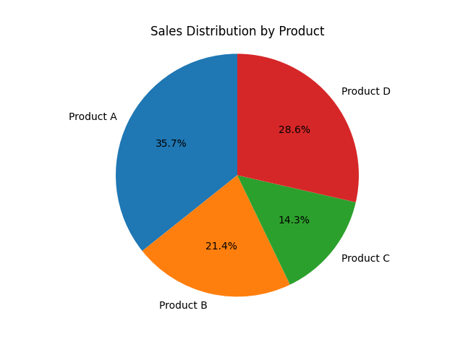

- Scatter plot

import matplotlib.pyplot as plt
# Sample data
x = [5, 7, 8, 7, 6, 9, 5, 8, 7, 9]
y = [99, 86, 87, 88, 100, 86, 103, 87, 94, 78]
# Create scatter plot
plt.scatter(x, y, color='blue', marker='o', s=100, alpha=0.7)
# Labels and title
plt.xlabel("X Values")
plt.ylabel("Y Values")
plt.title("Simple Scatter Plot Example")
# Show grid for better readability
plt.grid(True)
# Display plot
plt.show()
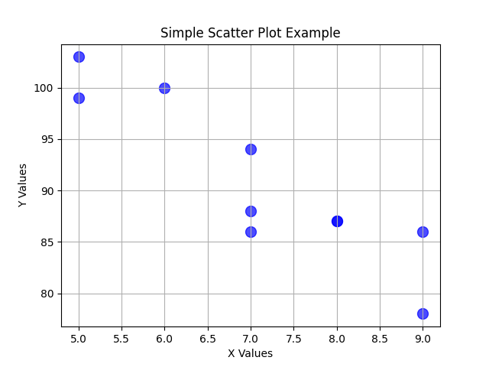

- Boxplot

import matplotlib.pyplot as plt
# Sample data
data = [7, 8, 5, 6, 9, 12, 15, 14, 8, 7, 6, 9, 10, 12, 11]
# Create boxplot
plt.boxplot(data)
# Labels and title
plt.xlabel("Dataset")
plt.ylabel("Values")
plt.title("Simple Boxplot Example")
# Show grid for clarity
plt.grid(True)
# Display the plot
plt.show()

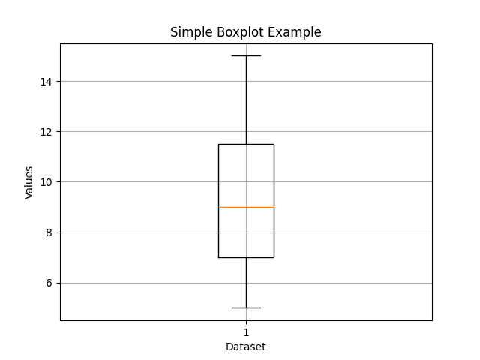

- Saving charts
In both Matplotlib and Seaborn, you can save charts to files (PNG, JPG, PDF, SVG, etc.) using the same underlying Matplotlib function:

import seaborn as sns
import matplotlib.pyplot as plt
import pandas as pd
# Sample DataFrame
df = pd.DataFrame({"x": [1, 2, 3, 4], "y": [10, 20, 25, 30]})
# Plot
sns.lineplot(data=df, x="x", y="y")
plt.title("Seaborn Example")
# Save chart
plt.savefig("seaborn_chart.png", dpi=300, bbox_inches='tight')
plt.show()

Tips for Saving
dpi=300 → High resolution (good for print).
bbox_inches='tight' → Trims extra whitespace around the chart.
Change file extension (.jpg, .pdf, .svg) to save in different formats.
Save before plt.show() — otherwise, the figure might reset.

- Grids
In Matplotlib and Seaborn, grids help make charts easier to read by showing horizontal/vertical reference lines.

import matplotlib.pyplot as plt
x = [1, 2, 3, 4]
y = [10, 20, 25, 30]
plt.plot(x, y, marker='o')
# Add grid
plt.grid(True) # Default grid
plt.title("Matplotlib with Grid")
plt.xlabel("X-axis")
plt.ylabel("Y-axis")
plt.show()

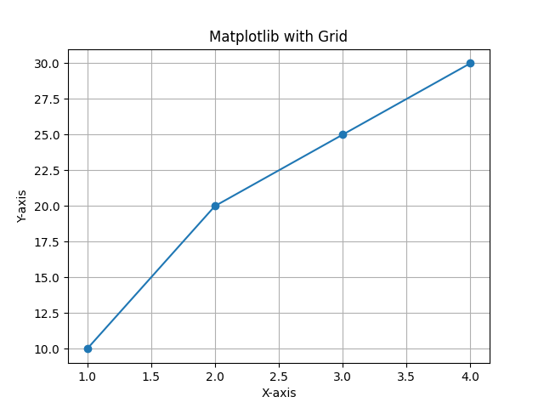

Customizing the Grid
plt.grid(
color='Red', # Grid line color
linestyle='--', # Dashed lines
linewidth=0.7, # Line thickness
alpha=0.7 # Transparency
)
You can also control which axis shows the grid:
plt.grid(axis='x') # Only vertical grid lines
plt.grid(axis='y') # Only horizontal grid lines

- Subplots
Subplots let you display multiple charts in one figure.
import matplotlib.pyplot as plt

x = [1, 2, 3, 4]
y1 = [10, 20, 25, 30]
y2 = [5, 15, 20, 25]

# Create figure and subplots (1 row, 2 columns)
fig, ax = plt.subplots(1, 2, figsize=(10, 4))

# First subplot
ax[0].plot(x, y1, marker='o')
ax[0].set_title("Line Chart 1")
ax[0].grid(True)

# Second subplot
ax[1].bar(x, y2)
ax[1].set_title("Bar Chart 2")
ax[1].grid(True)

plt.tight_layout() # Adjust spacing
plt.show()

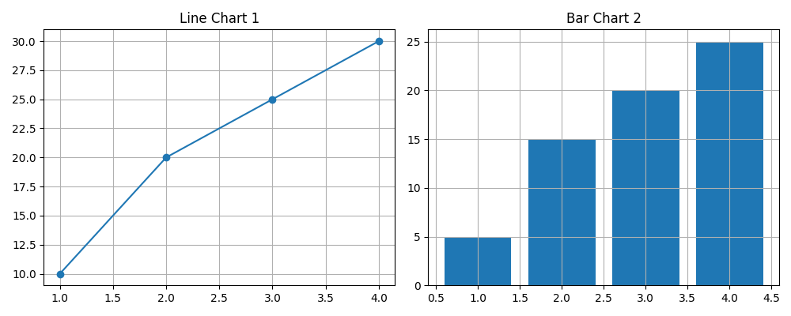
Subplots with Seaborn
import seaborn as sns
import pandas as pd
import matplotlib.pyplot as plt

# Sample DataFrame
df = pd.DataFrame({
"x": [1, 2, 3, 4],
"y1": [10, 20, 25, 30],
"y2": [5, 15, 20, 25]
})
# Create subplots
fig, ax = plt.subplots(1, 2, figsize=(10, 4))
# First subplot (line)
sns.lineplot(data=df, x="x", y="y1", ax=ax[0])
ax[0].set_title("Line Chart")
ax[0].grid(True)
# Second subplot (bar)
sns.barplot(data=df, x="x", y="y2", ax=ax[1])
ax[1].set_title("Bar Chart")
ax[1].grid(True)
plt.tight_layout()
plt.show()
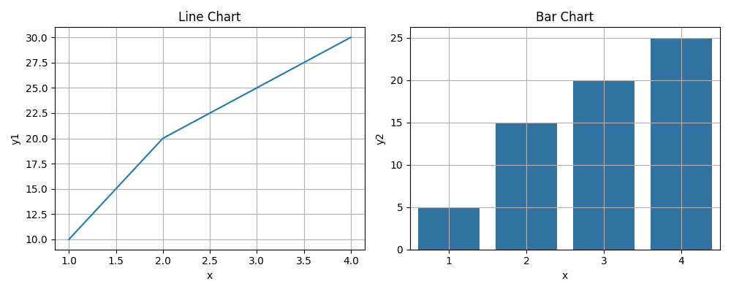

- Heatmaps
Heatmap with Seaborn (Correlation Matrix Example)

import seaborn as sns
import pandas as pd
import matplotlib.pyplot as plt
# Sample Data
df = pd.DataFrame({
"A": [1, 2, 3, 4],
"B": [4, 3, 2, 1],
"C": [10, 20, 25, 30]
})
# Compute correlation matrix
corr = df.corr()
# Create heatmap
sns.heatmap(corr, annot=True, cmap="coolwarm", linewidths=0.5)
plt.title("Correlation Heatmap")
plt.show()
